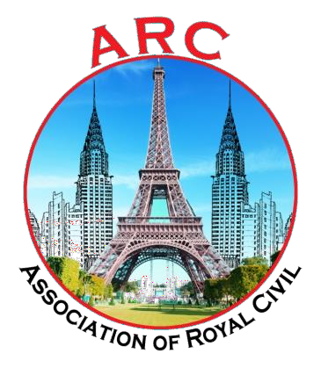

### CIVIL INFO

### 2K21-22

**VOLUME- VIII**

**ISSUE- I**

**EDITORIAL FACULTY**

**B.Ramya sri**

**Assistant Professor**

# Principal’s Message

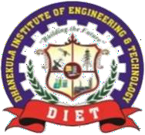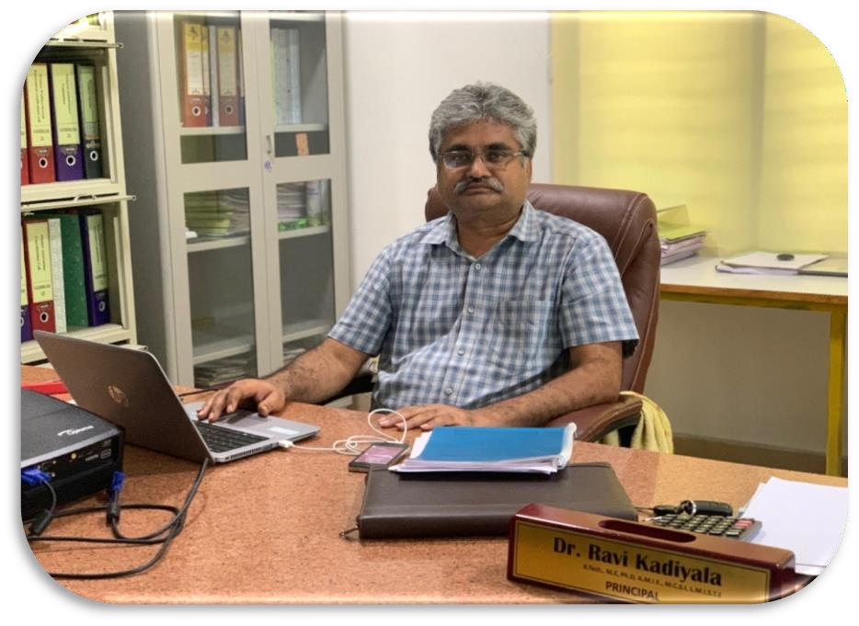

###### Dear Parents and Students,

It is with great pleasure that I welcome you to our College (DIET) Newsletter.

As Principal I am hugely impressed by the commitment of the college and the staff in providing an excellent all-round education for our students with our state of the art facilities. We as a team working together, strongly promote the zeal towards academic achievement among our students. The cultural, sporting and other successes of all our students and staff are also proudly celebrated together.

I congratulate the staff and students who brought latest technologies and concepts onto the day to day teaching learning platform. As long as our ideas are expressed and thoughts kindled we can be sure of learning, as everything begins with an idea.

I appreciate every student who shared the joy of participation in co-curricular and extracurricular activities along with their commitment to curriculum. That little extra we do, is the icing on the cake. ‘Do more than belong – participate. Do more than care – help. Do more than believe – practice. Do more than be fair – be kind. Do more than forgive – forget. Do more than dream – work.’

With a long and rewarding history of achievement in education behind us, our DIET community continues to move forward together with confidence, pride and enthusiasm.

I hope you enjoy your visit to the website and should you wish to contact us, please find details at the [www.diet.ac.in/](http://www.diet.ac.in/)

Yours in Education, Dr.Ravi Kadiyala

Principal

# Head of the Department ‘s Message



Civil Engineering is considered as back bone of nation’s development. The Civil Engineering department of DIET, Vijayawada was established in the year 2010 with an intake of 60 and later upgraded to the intake of 120. The Department has been now elevated to its next podium by offering Post Graduation in Environmental Engineering and consultancy services. The Civil Department have excellent infrastructure and state-of-the-art laboratories including Transportation, Fluid Mechanics and Hydraulics, Environmental, GIS and CAD, Structural and Strength of Materials labs, which are well-maintained by technically qualified personnel. Also, department has R&D and consultancy services where several research and consultancy projects were carried on materials testing, designing, planning and execution of several civil projects. Our department strength is our faculty who are devoted to educate our students and strengthen them such that they are ready to serve the nation as professionals, research scholars, academic leaders and entrepreneurs. The department offers concept oriented teaching-learning process coupled with practical knowledge through industry-Institute interaction. Industry personnel are invited to department as adjunct faculties to share their practical experience and knowledge. To enhance the technical and employability skills of our students, the Department encourages the students to undertake internship and in-plant training. Apart from regular curriculum, the department conducts Workshops/Guest Lectures/Industrial Visits for the students to augment their proficiency. The department has a well established mentoring system which provides individual attention to the students in the academic and other activities. The department also encourages its students to engage in extra-curricular and co-curricular activities to nurture their team spirit and develop organizational skills. In addition, the faculty members of the department are promoted to attend/conduct training programmes/FDP’s to keep them updated.

Yours in Education,

**Dr.G. Vinay Kumar**

HOD

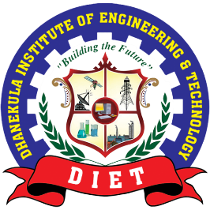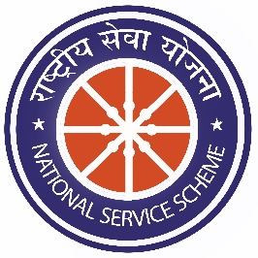

**NSS**

**NATIONAL SERVICE SCHEME**

On the eve of **NSS DAY 2021-22, 24-09-2021**, College NSS unit have organized events (Quiz, Poster Presentation, Mosaic, Debate and Skirt) at college Auditorium premises, the session have received encouraging response from student volunteers of NSS

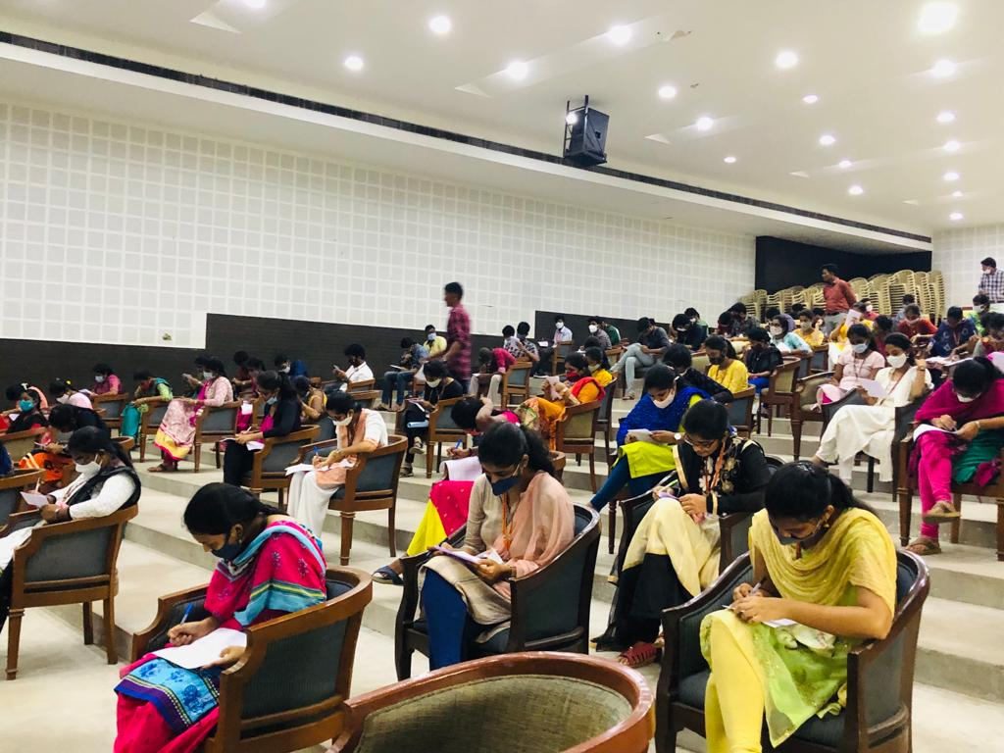

Almost 126 Students, 20 Student volunteers with NSS Program officer and staff coordinators have participated and made the session fruitful.

.

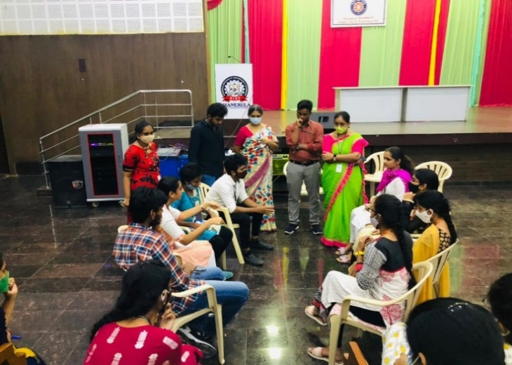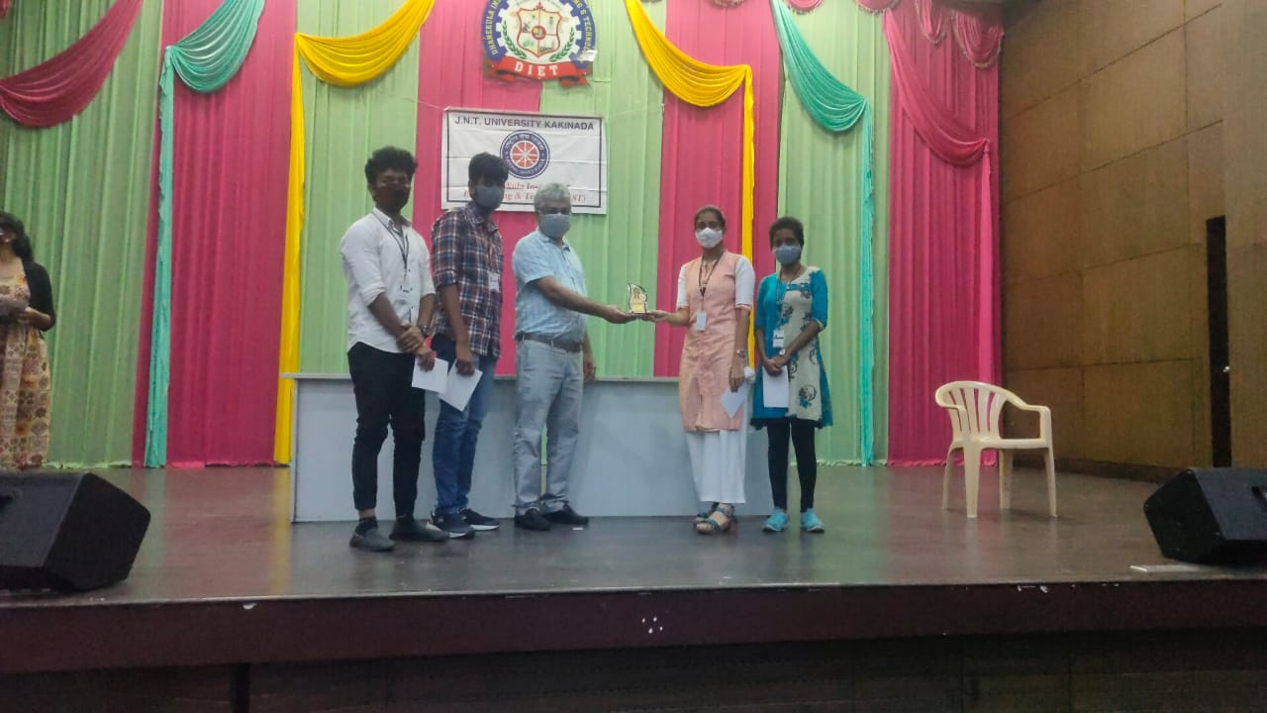

College NSS unit honored 124 certificates who have participated actively in various events, mementos for winners and runners. The session was conducted at ECE Seminar Hall and was presided by Dr. Ravi Kadiyala, principal of the institution.



Staff Articles

1. **Asset Mapping**

This **technique**focuses on **operational equipment**, including **heating**and **air conditioning**, **lighting**, and **security systems**, **collecting data**from **serial numbers**, firmware, **engineering notes**of when it was **installed**and by whom, and **combines**the **data**in **one place**.

It shows **engineers**in **real**–**time** on a **map**where the **equipment**needs to be **installed**and, once the **assets**are **connected**to the real-time system **using**the **internet**.

These can be **operated** via the **web, app, and other remote devices and systems.**

[**Asset mapping**](https://backspace.com/notes/2004/06/what-is-asset-mapping.php#:~:text=An%20asset%20map%20is%20an,how%20to%20access%20those%20assets.) helps **customers**build **databases**of asset **performance**, which can assist in **proactive building maintenance**, and also **reduce**building **procurement**and **insurance**costs.

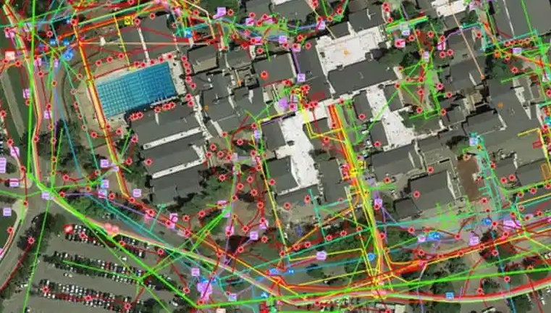

### **Asset Mapping**

**M.VINEELA**

ASSISTANT PROFESSOR

CIVIL DEPARTMENT



Staff Articles

### 

### **Photovoltaic Glaze**

[**Glazing integrated photovoltaic (BIPV)**](https://www.skyfilabs.com/project-ideas/photovoltaic-glazing-system#:~:text=Building%20integrated%20photovoltaic%20glazing%20(BIPV,also%20part%20of%20the%20building.) can **help**buildings **generate**their **own electricity**, by **turning**the **whole building envelope**into a **solar panel**.

[**Polysolar**](https://www.polysolar.co.uk/)is a **company**is to **provide transparent photovoltaic glass** as a **structural building material**, forming windows, **façades**, and **roofs**.

The **gazing material of Polysolar’s** is **efficient**at producing **energy**even on **north**–**facing**, **vertical walls**.

It is **high performance**at raised **temperatures**means it can be **double glazed**or **insulated directly**.

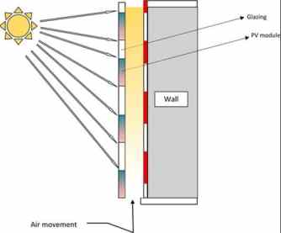

### **Photovoltaic Glaze**

**M.VINEELA**

ASSISTANT PROFESSOR

CIVIL DEPARTMENT