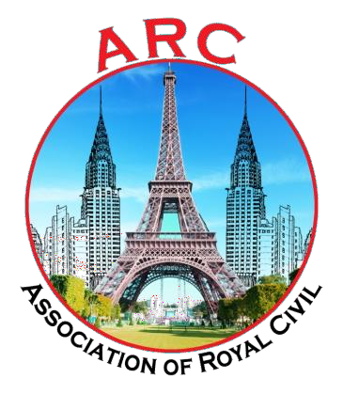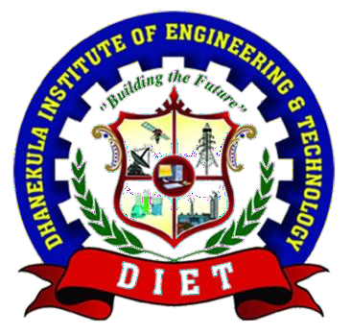

CIVIL INFO

FEBRUARY-MARCH

2K20-21

VOLUME-VII
ISSUE- V

EDITORIAL FACULTY

B. Ramya Sri
Assistant Professor

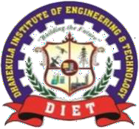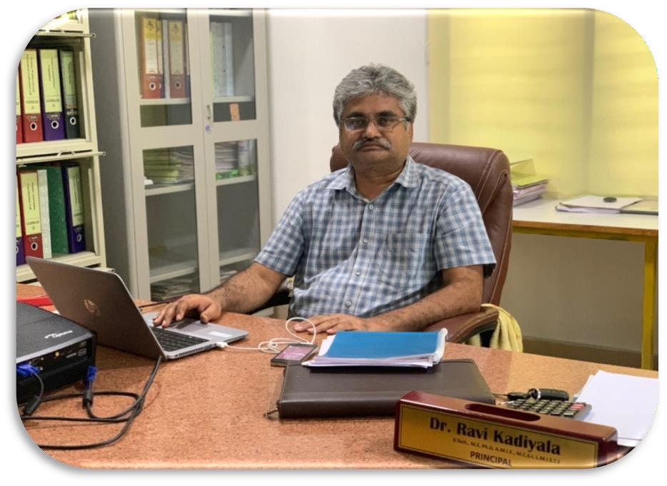Principal’s Message

Dear Parents and Students,
It is with great pleasure that I welcome you to our College (DIET) Newsletter.

As Principal I am hugely impressed by the commitment of the college and the staff in providing an excellent all-round education for our students with our state of the art facilities. We as a team working together, strongly promote the zeal towards academic achievement among our students. The cultural, sporting and other successes of all our students and staff are also proudly celebrated together.

I congratulate the staff and students who brought latest technologies and concepts onto the day to day teaching learning platform. As long as our ideas are expressed and thoughts kindled we can be sure of learning, as everything begins with an idea.

I appreciate every student who shared the joy of participation in co-curricular and extracurricular activities along with their commitment to curriculum. That little extra we do, is the icing on the cake. ‘Do more than belong – participate. Do more than care – help. Do more than believe – practice. Do more than be fair – be kind. Do more than forgive – forget. Do more than dream – work.’

With a long and rewarding history of achievement in education behind us, our DIET community continues to move forward together with confidence, pride and enthusiasm.
I hope you enjoy your visit to the website and should you wish to contact us, please find details at the www.diet.ac.in/
Yours in Education, Dr.Ravi Kadiyala
Principal

Head of the Department ‘s Message

Civil Engineering is considered as back bone of nation’s development. The Civil Engineering department of DIET, Vijayawada was established in the year 2010 with an intake of 60 and later upgraded to the intake of 120. The Department has been now elevated to its next podium by offering Post Graduation in Environmental Engineering and consultancy services. The Civil Department have excellent infrastructure and state-of-the-art laboratories including Transportation, Fluid Mechanics and Hydraulics, Environmental, GIS and CAD, Structural and Strength of Materials labs, which are well-maintained by technically qualified personnel. Also, department has R&D and consultancy services where several research and consultancy projects were carried on materials testing, designing, planning and execution of several civil projects. Our department strength is our faculty who are devoted to educate our students and strengthen them such that they are ready to serve the nation as professionals, research scholars, academic leaders and entrepreneurs. The department offers concept oriented teaching-learning process coupled with practical knowledge through industry-Institute interaction. Industry personnel are invited to department as adjunct faculties to share their practical experience and knowledge. To enhance the technical and employability skills of our students, the Department encourages the students to undertake internship and in-plant training. Apart from regular curriculum, the department conducts Workshops/Guest Lectures/Industrial Visits for the students to augment their proficiency. The department has a well established mentoring system which provides individual attention to the students in the academic and other activities. The department also encourages its students to engage in extra-curricular and co-curricular activities to nurture their team spirit and develop organizational skills. In addition, the faculty members of the department are promoted to attend/conduct training programmes/FDP’s to keep them updated.

Yours in Education,

Dr.G. Vinay Kumar
HOD

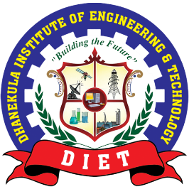
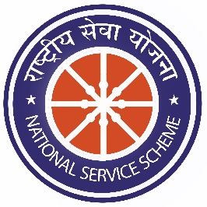
NSS
NATIONAL SERVICE SCHEME

On 11.02.21 The institution NSS unit has organized "32nd National Traffic Awareness Program" presided by Shri T. Sircar ASP, Vijayawada Traffic Police in the college auditorium. The minimum traffic rules, cell phone riding, triple riding, alcohol consumption and importance of helmet are some of the aspects where students have been educated by ACP K. Damodar, CI Ch.P.Krishnaraju and CI A. Umamaheswara Rao. Road Safety NGO director M.Vasu have also participated in the program where he have given interesting insights into the issue in a creative way. The institution principal Dr.Ravi Kadiyala also stressed upon the importance of various measures to be taken for road safety.

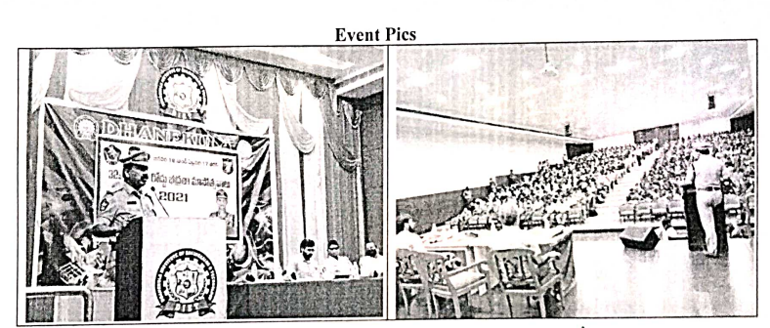

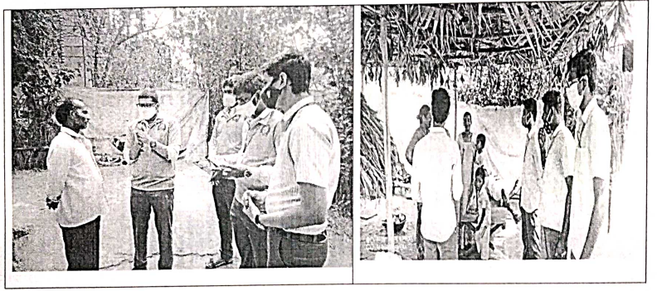
.
On 18-02-21 NSS UNIT have organized a Door-to-Door campaign on "PLASTIC AWARENESS" and "SOIL CONSERVATION in Madduru Village. Around 50 Volunteers have participated in this awareness campaign.Volunteers have educated the people in the village about the harmful effects of plastic on Health, Environment, Wildlife and urged them to avoid single use plastic.
and urged.

The Institution NSS Cell along with JNTUK has planned a 3-Day Special Camp in Edupugallu Village from 18/02/2021 to 20/02/2021, which is sponsored by JNTU Kakinada. For educating the people regarding Health, Environment and Importance of Education, we seek your permission and support for conduct of these programs in the village.

As a part of NSS SPECIAL CAMP, DHANEKULA NSS UNIT have organized a seminar on "Career Prospects and Open Defecation" in Z.P. High School in Edupugallu Village. Around 50 Volunteers have participated in program. Volunteers have demonstrated the students about the importance of education in the current era and its significance.
The different career prospects with their responsibilities and advantages were thoroughly explained to the young minds, which encouraged the students to understand the benefits of education.

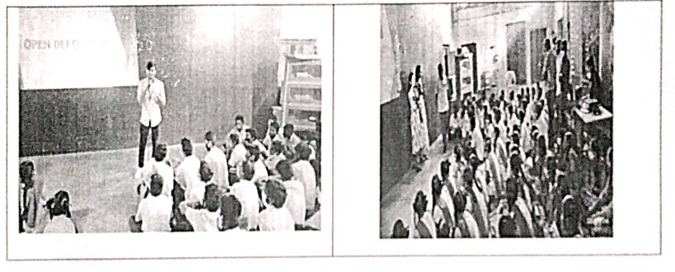

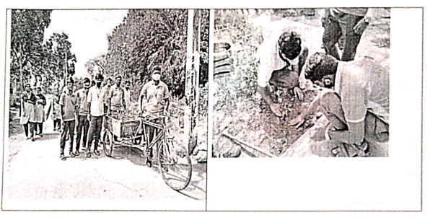
As a part of NSS SPECIAL CAMP, DHANEKULA NSS UNIT have organized "TREE PLANTATION" in Edupugallu Village. Around 50 Volunteers have participated in this campaign. The volunteers have distributed and planted various trees throughout the village signifying the importance of trees for our health and environment.

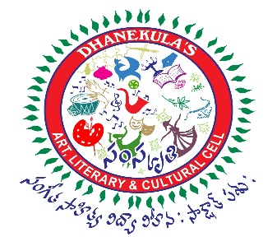
SAMSKRUTHI

Recognizing the excellent efforts of students expresses the importance of hard work, while providing students with a positive self-worth and high level of accomplishment .Academic Excellence Awards is an ideal platform to reward this attitude among our students in the field of academics. It is an effort to specially acknowledge their hard work, perseverance and precision in achieving their academic goals.

The Annual Excellence Awards for the academic year 2019-2020 was conducted on 08-02-2021.Sri Dinesh Kumar Batra Director (Finance) of Navratna Defence, PSU, Bharat Electronics was the Chief guest of the occasion and presented gold and silver medals to meritorious students

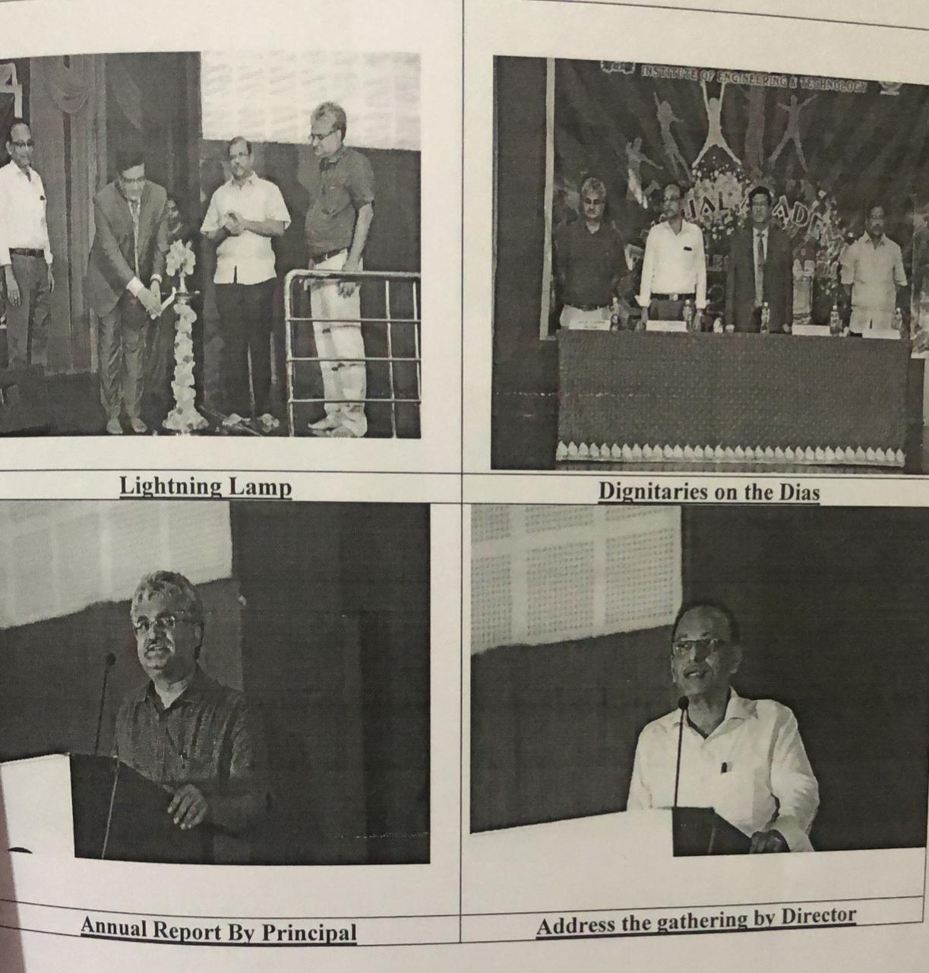

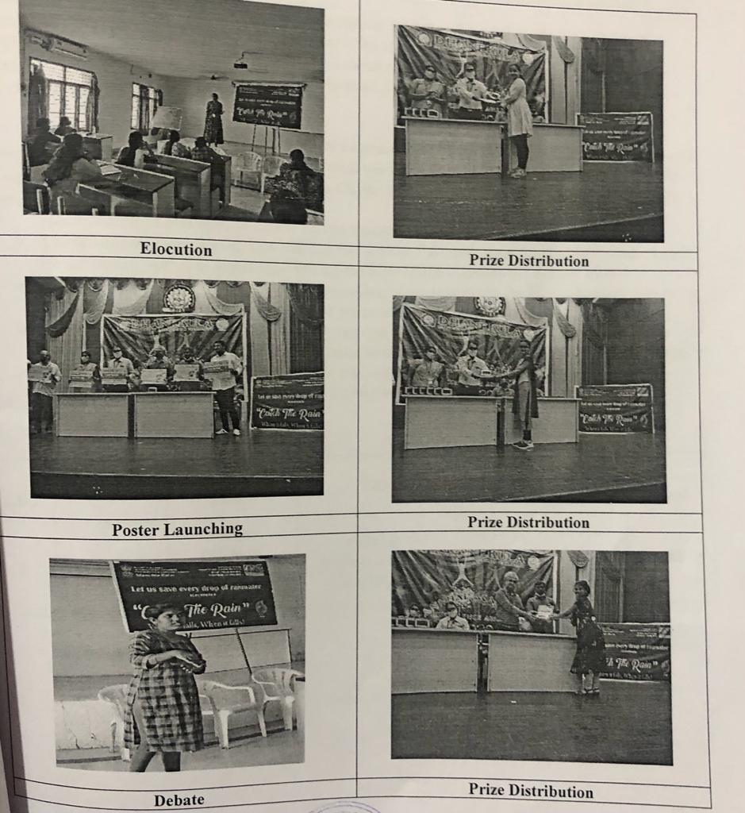
SAMSKRUTHI
As a part of this campaign on the eve of National Science Day five events are Organized by National Water Mission under Jal Sakthi Abhiyan 2 with the Collaboration of Nehru YuvaKendra, Vijayawada. The event was Coordinated by Dhanekula's Samskruthi -Art, Literary & Cultural Cell.

National Water Mission's (NWM) campaign "Catch The Rain" with the tagline "Catch the rain, where it falls, when it falls" is to encourage the states to create appropriate Rain Water Harvesting Structures (RWHS) suitable to the climatic conditions
On 26-02-2021 eve of National science day every year on 28 February to mark the discovery of the Raman Effect by Sri C.V Raman the NSD is celebrated with a view to spread the message about the significance of science and how it improves the daily lives of the common folk.

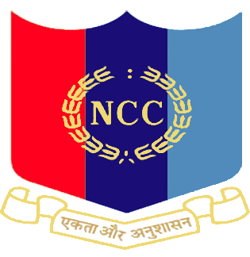
NCC

NATIONAL CADET CORPS

From 08.02.2021 to 12.02.2021 Dhanekula NCC Cadets attend the CADER CAMP on at PVP Siddhartha Engineering College, Kanuru.

